Motivators: The Altruistic Motivator
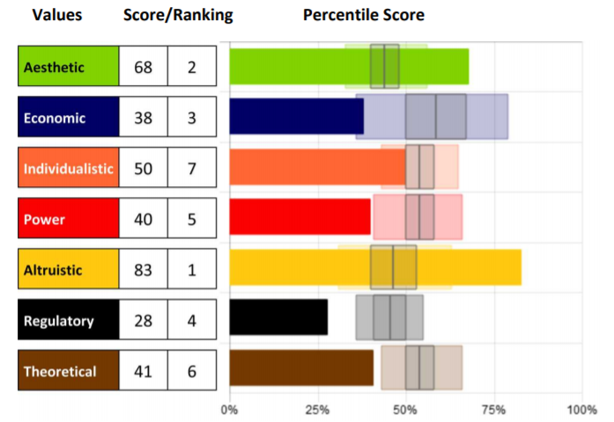
Knowing our specific level of
motivation can be crucial to
helping us understand what
drives our beliefs and actions so
we can bring them into
alignment.

Remember that although we can
explore each motivation individually, they cannot be separated. They can only be
distinguished; however, all motivators integrate to influence us.

The Altruistic Motivator - the drive to benefit others at the expense
of self

This motivation is an expression of the need or energy to benefit
others at the expense of self. Personal sacrifice is key to high
scores in this dimension. At times there is a genuine sincerity to help
others, but not always; this can also be a sign of low self-worth.

Scores high in this motivator exude empathy; they associate easily
with the feelings of others and may feel them too. Those high in this
motivation will help and accommodate anyone and everyone, while
those lower in this motivation will be more discerning about who
deserves their support.

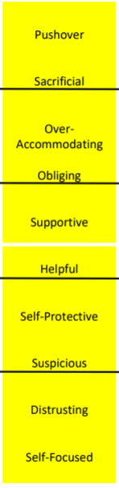
Using this descriptor scale, you can identify a key component to each person’s score in this motivation, as well as see how the scores range from Very Low to Very High, noted by the black lines between each set of descriptors. Each word represents 10 points of 100 on the scale (example: Suspicious people score between 20-29, Sacrificial people score between 80-89 in this dimension).
The white line indicates 50%, perfect balance between high and low in the motivation. Those who score closer to 50% will be situational in applying this motivator. Moving further from that line (high or low) indicates which areas are the more influential.

Whether scores are high or low, the motivators with the furthest distance above or below 50% (above or below “perfect balance” in the center) will be the highest influencers leading to the greatest impact on the decisions being made.

Strengths and Limitations

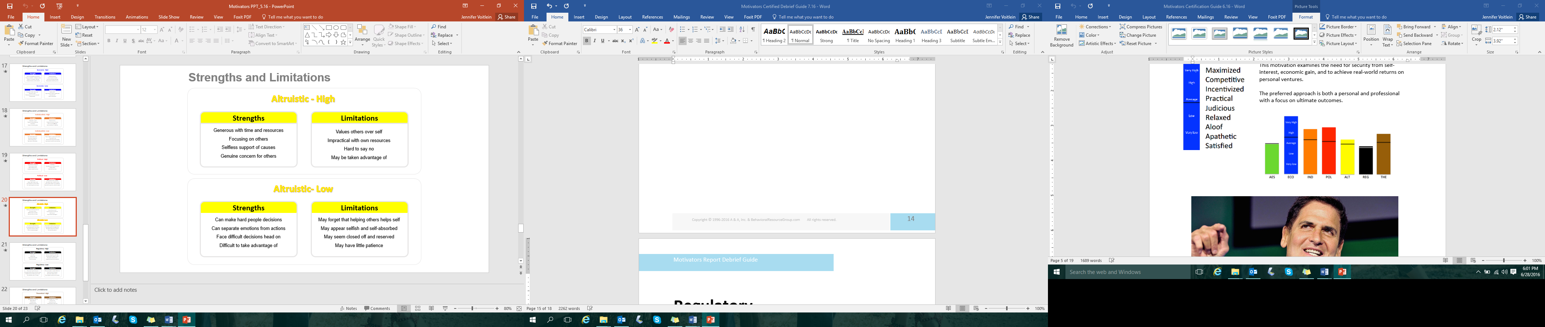

- What drives you in this motivation?
- How can that be helpful and productive for you?
- How can that limit you?

Assessments 24x7 LLC 5927 Balfour Court, Ste. 103 Carlsbad, California 92008 USA (206) 400-6647

